THEODORE ROOSEVELT HIGH SCHOOL
CADET STUDY GUIDE

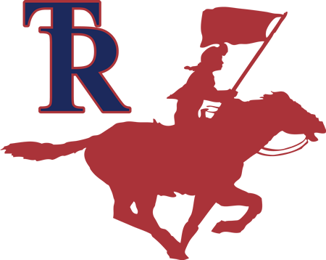

PROPERTY OF CADET__________________________________

THE JROTC CADET CREED
I am an Army Junior ROTC Cadet. I will always conduct myself to bring credit to my family, country, school, and the Corps of Cadets. I am loyal and patriotic. I am the future of the United States of America. I do not lie, cheat, or steal and will always be accountable for my actions and deeds. I will always practice good Citizenship and Patriotism. I will work hard to improve my mind and strengthen my body. I will seek the mantel of leadership and stand prepared to uphold the Constitution and the American way of life. May God grant me the strength to always live by this creed.
GENERAL ORDERS
1. I will Guard everything within the limits of my post and quit my post only when properly relieved.
2. I will Obey my special orders and perform all of my duties in a military manner.
3. I will Report violation of my special orders, emergencies and anything not covered in my instructions to the commander of the relief.
OBJECTIVES
Mission of JROTC: To motivate young people to be better citizens.
1. Good citizens and patriotism
2. Self-reliance, self-discipline, organization, leadership abilities, and respect for the constituted authorities.
3. Good habits of hygiene, bearing, and physical fitness.
4. The ability to communicate effectively both orally and written.

CHAIN OF COMMAND

President (POTUS)/Commander in Chief: ________________________
Vice President: ________________________________________
Secretary of State: ________________________________________
Secretary of Defense: ________________________________________
Secretary of the Army: ________________________________________
Chairman of the Joint Chiefs: ________________________________________
Chief of Staff, U.S Army: ________________________________________
Training & Doctrine Command (TRADOC) Commander: _______________________________
Cadet Command Commander: ________________________________________
5th Brigade Commander______________________________________
Senior Army Instructor (SAI): ________________________________________
Governor of Texas: _____________________________________
San Antonio Mayor: ___________________________________
SERGEANTS MAJOR OF THE ARMY
Sergeant Major of the Army: _______________________
(TRADOC) Sergeant Major: _______________________
Cadet Command CSM: _______________________________________
5th Brigade CSM: ________________________________________
Army Instructor (A.I.): ______________________________
ROUGH RIDER BATTALION CHAIN OF COMMAND
Battalion Commander (BC): __________________________
Battalion Executive Officer: _____________________________________
Battalion Command Sergeant Major (CSM): ________________________________________
Company Commander: ________________________________________
Company First Sergeant: ________________________________________
Company Executive Officer: ______________________________________

PHONETIC ALPHABET

A – Alpha J-Juliet S-Sierra
B – Bravo K-Kilo T-Tango
C – Charlie L-Lima U-Uniform
D-Delta M-Mike V-Victor
E-Echo N-November W-Whiskey
F-Foxtrot O-Oscar X-Xray
G-Golf P-Papa Y-Yankee
H-Hotel Q-Quebec Z-Zulu
I-India R-Romero

KEY MANUALS

Cadet Command Regulation (CCR) 145-2 – Organization, Administration and Operations Training Circular

(TC) 3-21.5 – Drill and Ceremony

Army Regulation 670-1 – Uniform Standards

Field Manual 6-22 – Leadership

DRILL AND CEREMONY
The purpose of drill: Drill enables a leader to move his/her unit from one location to another; aids in discipline, provides a way to conduct ceremonies; and provides a way to practice commanding troops.
➢ What is the name and number of the current drill and ceremony regulation?
Army Training Circular (TC) 3- 21.5 Drill and Ceremony
➢ Who wrote the first Army Field Manual on drill (also known as the BLUE BOOK)?
Baron Von Stueben
➢ What are the three methods to teach drill?
Step-by-step, talk through, and by-the-numbers.
➢ What is interval?
Lateral space between members in the same squad/team.
➢ What is distance?
Space between the person in front and in back of you.
➢ What are the two parts of an oral drill command?
Preparatory command and command of execution
➢ What is a supplementary command?
Oral orders given by a subordinate leader that reinforce and complement a commander’s order.
➢ What is the purpose of a supplementary command?
To ensure proper understanding and execution of movement.
➢ Why would you use mass commands?
1) To develop confidence 2) Promote enthusiasm 3) Develop a command voice
➢ What command is given to revoke a preparatory command?
AS YOU WERE

➢ What is the only directive in which a commander relinquishes his command and on which salutes are exchanged?
TAKE CHARGE OF YOUR UNITS

➢ FALL IN, AT EASE, and REST are an example of what type of command?
Combined commands
➢ How many inches are the feet apart at parade rest?
10 inches
➢ What are your actions on the command STAND AT EASE?
Execute parade rest, turn the head and eyes directly toward the person in charge of the formation.
➢ What is the only rest position that you are allowed to talk?
REST
➢ What are the two prescribed formations for a squad?
Line and column
➢ What are the commands to align a squad at normal interval?
DRESS RIGHT, DRESS and READY, FRONT
➢ What are the commands to align a squad in a column?
COVER and RECOVER
➢ What is the command to form a column formation from a line formation and ensure your subordinate leaders are in the correct position?
RIGHT FACE.
➢ How do you measure a marching step?
From heel to heel.
➢ How many inches in a marching step?
30 inches.
➢ How many inches in a half step?
15 inches

➢ How many inches in a BACK STEP?
15 inches.
➢ How many inches should the feet be raised off the marching surface when MARKING TIME?
Two inches
➢ What is the cadence for quick time?
120 steps per minute.
➢ What is the cadence for double time?
180 steps per minute.
➢ What is the approximate arm swing when marching?
9 inches to the front; 6 inches to the rear.
➢ When DOUBLE TIMING, what must you do before you salute?
Come to QUICK TIME
➢ When a formation is marching at DOUBLE TIME, who assumes QUICK TIME and salutes?
Only the individual in charge of the formation.
➢ When executing movement from the halt, what is the only movement that does not begin with the left foot?
RIGHT STEP, MARCH.
➢ On what foot is the command COUNT CADENCE COUNT given?
Left
➢ On which foot is the command CHANGE STEP, MARCH given?
Right foot.
➢ On which foot, can the command HALF STEP, MARCH be given?
Either foot.
➢ To halt when executing RIGHT or LEFT STEP, when should the preparatory and command of execution be given?
When the heels are together.

➢ What is the command to march backwards?
BACKWARD, MARCH.
➢ When marching at QUICK TIME, on which foot is the command DOUBLE TIME, MARCH given?
Either foot.
➢ On which foot is COLUMN LEFT, MARCH given?
Left
➢ On which foot is COLUMN RIGHT, MARCH given?
Right.
➢ On which foot is REAR, MARCH given?
Right.
➢ When marching on what foot is the command EYES, RIGHT given?
Right
➢ When marching on what foot is the command READY, FRONT given?
Left
➢ To avoid an obstacle in the line of march, what directive would be given?
Incline around
LEADERSHIP
➢ What is the definition of leadership?
The process of influencing others to accomplish the mission by providing purpose, direction, and motivation.
➢ What is the definition of discipline?
Instant willing obedience to all orders, respect for authority, self-reliance, and teamwork.
➢ What are the four factors of leadership?
The Led, the leader, the situation and communication.
➢ What are the three styles of leadership?
Directing, Delegating, and Participating.

➢ The 11 principles of leadership:
1) Know yourself and seek self-improvement.
2) Be technically and tactically proficient.
3) Know your subordinates and look out for their welfare.
4) Train your subordinates as a team.
5) Keep your subordinates informed.
6) Set the example.
7) Inure the task is understood, supervised, and accomplished.
8) Make sound and timely decisions.
9) Develop a sense of responsibility among your subordinates.
10) Employ your command in accordance with its capabilities.
11) Seek responsibility and take responsibility for your actions.
14 LEADERSHIP TRAITS
1. Justice- The ability to administer a system of rewards and punishments impartially and consistently. 2. Judgement – The ability to weigh facts and possible courses of action in order to make sound decisions.
3. Dependability – The certainty of proper performance of Duty
4. Initiative – Taking action in the absence of orders
5. Decisiveness – Ability to make decisions promptly
6. Tact – The ability to deal with others without creating hostility
7. Integrity – Uprightness of character and soundness of moral principles
8. Endurance – The mental and physical stamina measured by the ability to withstand pain, fatigue, stress, and hardship
9. Bearing – Creating a favorable impression in carriage, appearance, and personal conduct at all times
10. Unselfishness – Avoidance of providing for one’s own comfort and personal advancement at the expense of others
11. Courage – A mental quality that recognizes fear of danger or criticism, but enables a soldier to proceed in face of adversity calmly
12. Knowledge – The range of one’s information, including professional knowledge and an understanding of your soldiers
13. Loyalty – The quality of faithfulness to country, the Corps, and unit, and to one’s seniors, subordinates, and peers
14. Enthusiasm – The display of sincere interest and exuberance in the performance of duty
➢ What are two types of courage?
Moral and physical.
➢ What is candor?
Being frank, open, honest, and sincere with subordinates, seniors, and peers.
➢ What is character?
Your inner strength- doing what you believe is rights, regardless of danger or circumstances.
➢ Being a good leader is an important part of what concept?
Being a good follower
LAND NAVIGATION/ORIENTEERING
➢ What is a map?
A scaled, geographical representation of the earth’s surface as seen from above.
➢ How do you read coordinates on a map? Right and up.
➢ What is a scale on the map?
Shows the relationship between map distance and ground distance.
➢ What are the types of major terrain features?
Hill, valley, depression, ridge, saddle, spur, and draw.
➢ What is the color blue on a map?
Water such as lakes, rivers, and swamps.
➢ What is the color black on a map?
Man-made features such as buildings, roads, and railroads.
➢ What is the color green on a map?
Vegetation

➢ What is the color red on a map?
Major roads, highways, and populated areas.
➢ What is the color brown on a map?
Elevation and relief depicted with contour lines.
➢ What are contour lines?
Brown lines on a map that shows elevation and relief.
➢ What are three types of contour lines on a map?
Index, supplementary and intermediate.
➢ What are three types of North?
True, magnetic, and Grid North.
➢ How is Grid north depicted on a map?
Letters GN
➢ How is True north depicted on a map?
A STAR
➢ How is Magnetic north depicted on a map?
Half arrowhead.
➢ What is a G-M angle?
The angle between Grid North and Magnetic North.
➢ What is a declination diagram on a map?
Shows the angular relationship between true, grid and magnetic north.
➢ What is an azimuth?
A horizontal angle measured clockwise from north.
➢ How do you compute a back azimuth?
Add or subtract 180 degrees.
➢ How many degrees in a circle?
360 degrees.

➢ What are the units used to measure distance on a map?
Miles, meters, and yards.
➢ What is the formula for determining actual ground distance on a map when bar scales are not available?
Map Distance x Scale = Ground Distance
➢ What instrument is used to read coordinates on a map?
Coordinate scale.
➢ What instrument is used to measure an azimuth on a map?
Protractor
➢ What instrument is used to measure a magnetic azimuth?
Compass

FIRST AID
➢ Define First Aid?
Emergency care given to sick, injured, or wounded, before professional medical help arrives.
➢ List the 4 Lifesaving steps.
1) Open the airway and restore breathing.
2) Stop the bleeding.
3) Protect the wound.
4) Treat for shock.
➢ What is the name of the maneuver used on a choking victim?
Heimlich Maneuver.
➢ What is the Heimlich Maneuver used for?
Clear a blocked airway.
➢ What does artificial respiration use for?
To restore breathing.

➢ What does CPR stand for?
Cardio-Pulmonary Resuscitation

➢ When one person is performing CPR, how many times do you compress the heart?
30 times
➢ When one person is performing CPR for a child, how many times do you compress the heart?
30 times
➢ When one person is performing CPR for an infant, how many times do you compress the heart?
15 times
➢ What are 4 ways to stop the bleeding?
1) Pressure dressing
2) Elevation
3) Pressure points
4) Tourniquet
➢ What are the three types of blood vessels?
Vein, Arteries and Capillaries.
➢ Blood that is bright red in color and shooting out in spurts is an indication of what type of bleeding?
Arterial Bleeding.
➢ What is the last resort to stop the bleeding?
Tourniquet
➢ What is one case when you would always apply a tourniquet?
When an arm or leg has been completely severed

➢ How do you treat someone for shock?
1) Position the victim on the back unless a sitting position makes breathing easier.
2) Elevate the victim’s feet higher than the heart.
3) Loosen clothing.
4) Do not give any food or drinks
➢ What is likely to happen to a person with a severe injury?
They will go into shock.
➢ What are the two common types of fractures?
Simple and compound or open and closed.
➢ What is the most common injury caused by exposure to the cold?
Frostbite.
➢ What are the three types of heat injuries?
Heat cramps, Heat exhaustion, and Heat stroke
➢ What is the most serious type of heat injury?
Heat Stroke
➢ What is a normal heartbeat?
60 to 80 beats per minute.
➢ What are the signs/symptoms of shock?
1) Sweaty but cool skin
2) Paleness of skin
3) Restlessness
4) Thirst
5) Loss of blood
6) Confusion
7) Faster than normal breathing rate
8) Blotchy or bluish skin
9) Nausea and/or vomiting

UNITED STATES FLAG INFORMATION AND PROTOCOL
➢ What are the three most common types of flags?
Storm, Post, and Garrison
➢ What is the size of the Garrison Flag?
20 feet by 38 feet.
➢ What is the size of the Post Flag?
10 feet by 19 feet.
➢ What is the size of the Storm Flag?
5 feet by 9 ½ feet.
➢ How many stars are there on the United States flag?
50
➢ What color are the stars on the United States flag?
White
➢ What do the stars on the United States flag represent?
One for each state in the Union.
➢ What do the colors on the flag represent?
1) White – Purity
2) Red – Hardiness and Valor
3) Blue – Justice, Perseverance, and Vigilance
➢ How many stripes are there on the United States flag?
13 (There are 6 white stripes on the U.S. flag, and 7 red stripes)

➢ What do the stripes on the United States flag represent?
They represent the 13 original colonies
1. Virginia (First colony)
2. Massachusetts
3. New Hampshire
4. New York
5. New Jersey
6. Pennsylvania
7. North Carolina
8. South Carolina
9. Rhode Island
10. Connecticut
11. Maryland
12. Delaware
13. Georgia (Last of the first 13)
➢ Who created the first Stars and Stripes?
The Continental Congress of Philadelphia.
➢ In what year was the stars and stripes created?
1777
➢ After 1818, what did the white stars on the U.S. flag represent?
A star added for each state admitted to the union.
➢ When is Flag Day?
June 14
➢ How is the United States flag displayed on Memorial Day?
Half-staff until noon then raised to the top of the staff.
➢ What is Reveille?
Ceremony raising of the flag
➢ What is Retreat?
Ceremony lowering the flag
➢ What are the only 2 flags can be flown over the US flag?
The USN Church Pennant while flying at high sea and during services. United Nations flag in New York at UN Headquarters.

THE PLEDGE OF ALLEGIANCE
"I pledge allegiance to the Flag of the United States of America, and to the Republic for which it stands, one Nation under God, indivisible, with liberty and justice for all."
THE TEXAS PLEDGE
"Honor the Texas flag; I pledge allegiance to thee, Texas, one state under God, one and indivisible."
THE STAR-SPANGLED-BANNER (4 VERSES)
Verse 1: O say can you see, by the dawn's early light, what so proudly we hailed at the twilight's last gleaming, Whose broad stripes and bright stars through the perilous fight, O'er the ramparts we watched, were so gallantly streaming? And the rockets' red glare, the bombs bursting in air, gave proof through the night that our flag was still there; O say does that star-spangled banner yet wave O'er the land of the free and the home of the brave?
Verse 2: On the shore dimly seen through the mists of the deep, Where the foe's haughty host in dread silence reposes, what is that which the breeze, o'er the towering steep, As it fitfully blows, half conceals, half discloses? Now it catches the gleam of the morning's first beam, in full glory reflected now shines in the stream: 'Tis the star-spangled banner, O! long may it wave O'er the land of the free and the home of the brave.
Verse 3: And where is that band who so vauntingly swore That the havoc of war and the battle's confusion, A home and a country, should leave us no more? Their blood has washed out their foul footsteps' pollution. No refuge could save the hireling and slave from the terror of flight, or the gloom of the grave: And the star-spangled banner in triumph doth wave, O'er the land of the free and the home of the brave.
Verse 4: O thus be it ever, when freemen shall stand Between their loved homes and the war's desolation. Blest with victory and peace, may the Heav'n have rescued land Praise the Power that hath made and preserved us a nation! Then conquer we must, when our cause it is just, and this be our motto: "In God is our trust." And the Star - Spangled Banner in triumph shall wave O'er the land of the free and the home of the brave!

WHY THE AMERICAN FLAG IS FOLDED 13 TIMES
➢ Have you ever wondered why the flag of the United States of America is folded 13 times when it is lowered or when it is folded and handed to the widow at the burial of a veteran? Here is the meaning of each of those folds and what it means to you.
1. The first fold of our flag is a symbol of life.
2. The second fold is a symbol of our belief in eternal life.
3. The third fold is made of honor and remembrance of all the veterans departing our ranks who gave a portion of their lives for the defense of our country to attain peace throughout the world.
4. The fourth fold represents out weaker nature, for as American citizens trusting in God, it is to Him we turn in times of peace as well as in time of war for His divine guidance.
5. The fifth fold is a tribute to our country, for in the wards of Stephen Decatur, “Our Country, in dealing with other countries may she always be right; but it is still our country, right or wrong.”
6. The sixth fold is for where our hearts lie. It is with our heart that we pledge allegiance to the flag of the United States of America, and to the Republic for which it stands, one Nation under God, indivisible, with Liberty and Justice for all.
7. The seventh fold is a tribute to our Armed Forces, for it is through the Armed Forces that we protect our country and our flag against all her enemies, whether they be found within or without the boundaries of our republic.
8. The eighth fold is a tribute to the one who entered into the valley of the shadow of death, that we might see the light of day, and to honor mother, for whom if flies on Mother’s Day.
9. The ninth fold is a tribute to womanhood; for it has been through their faith, their love, loyalty, and devotion that the character of the men and women who have made this country great has been molded.
10. The tenth fold is a tribute to the father, for he, too, has given his sons and daughters for the defense of our country since they were first born…
11. The eleventh fold, in the eyes of a Hebrew citizen represents the lower portion of the seal of King David and King Solomon, and glorifies in their eyes, the God of Abraham, Isaac, and Jacob.
12. The twelfth fold, in the eyes of a Christian citizen, represents an emblem of eternity and glorifies, in their eyes, God the Father, the Son, and Holy Spirit.
13. When the flag is completely folded, the stars are uppermost reminding us of our nation’s motto, “In God We Trust”.
After the flag is completely folded and tucked in, it takes on the appearance of a cocked hat, ever reminding us of the soldiers who served under General George Washington, and the sailors and marines who served under Captain John Paul Jones, who were followed by their comrades and shipmates in the Armed Forces of the United States, preserving for us the rights, privileges, and freedoms we enjoy today

JROTC UNIFORM
➢ What class of uniform is normally worn during ceremonies, social functions, and formal inspections? The class “A” uniform
➢ The army blue coat is worn as a part of what Army uniform?
The class “A” uniform
➢ How should the JROTC uniform be worn?
With PRIDE
➢ What regulation covers the wear of the uniform?
CCR 670-1 and CCR 145-2.
➢ What uniform is worn during ceremonies and social functions?
The Class A or B uniform.
➢ What is the nomenclature of the shirt worn under the Army Service Uniform?
Gray 510 short sleeve shirt.
➢ What color t-shirt is worn with the class A or B uniform?
White.
➢ The black necktie/neck tab is optional when wearing what type of uniform?
Class B uniform with short sleeves.
➢ What color socks are worn with the class A or B uniform?
Black socks.
➢ What uniform is worn at summer camps and for participation on special teams?
ACU’s.
➢ What does ACU stand for?
Army Combat Uniform.
➢ What does OCP (New Army Combat Uniform) stand for?
Operational Camouflage Pattern
➢ What color t-shirt is worn with the ACU uniform?
Tan.
➢ What insignia do cadet officers wear on the beret?
Grade or rank insignia.
➢ What insignia do enlisted cadets wear on the beret?
ROTC insignia.
➢ How is the JROTC shoulder sleeve insignia worn on the class A uniform?
On the left sleeve, ½ inch below the shoulder seam.
➢ Where is the Honor Unit insignia worn?
¼ of an inch and centered above the top of the right pocket (or in a similar position on female uniforms using an imaginary horizontal line even with the first button).
➢ How are ribbons positioned on the class A uniform?
Ribbons are centered on the left side 1 /8 of an inch above the left pocket (or in a similar position on female uniforms using an imaginary horizontal line even with the first button).
➢ Does the tip of the black belt worn with the class A or B uniform have to be brass in color or shined?
No.
➢ How often must a uniform be worn by cadets?
At least once per week.
➢ Can a male cadet wear an earring in uniform?
No.
➢ What size earrings can female cadets wear in uniform?
Small spherical earrings not to exceed ¼ inch in diameter (basically studs)
➢ How should the nameplate be worn on your uniform?
Center the nameplate on the right pocket between the top of the pocket and the top of the button for males. For female cadets use an imaginary horizontal line even with the first button on the jacket or shirt.

➢ How are shoulder board ranks worn?
Cadet Officers places the pointed end toward the collar and the flat end toward the edge of the shoulder. Enlisted cadets place the side with the pointed chevron toward the collar.
➢ Who is authorized to wear shoulder cords? The instructor staff may authorize a cadet to wear shoulder cords for participation in certain JROTC activities. (i.e., color/honor guard or drill/rifle team).
GENERAL KNOWLEDGE
➢ What is the mission of JROTC?
To motivate young people to be better citizens
➢ What is the purpose of JROTC?
To develop leadership in cadets.
➢ What is the key to success in JROTC?
Teamwork
➢ In what year did the JROTC program start?
1916
➢ Who was the founder of JROTC?
Captain Alden Partridge
➢ What is the current total number of schools in the United States and outside (the U.S) where army JROTC is being taught?
Over 1700
➢ What are some of the skills you will learn in JROTC and use in school and throughout life?
How to lead, how to talk intelligently, and how to write clear and legibly
➢ How old should you be before you can enroll in the JROTC program?
Minimum age 14

➢ What are the 7 Army Values?
(LDRSHIP)
LOYALTY - To bear true faith and allegiance.
DUTY - To fulfill your obligations.
RESPECT - To treat people as they should be treated.
SELFLESS SERVICE - To put the welfare of the nation and others before your own.
HONOR - To live up to all values.
INTEGRITY - To do what is right, legally, and morally.
PERSONAL COURAGE - To face fear, danger, or adversity.
➢ What is another name for the national anthem of the United States?
The Star-Spangled Banner
➢ How many verses are in the National Anthem?
4 verses. First verse is normally sung
➢ Who wrote the Star-Spangled Banner?
Francis Scott Key
➢ When you salute during the playing of the “Star Spangled Banner”, what are you saluting?
THE NATION
➢ What are the first ten Amendments of the constitution called?
Bill of rights
➢ What does the bill of rights guarantee an accused person?
A speedy and public trial
➢ Why was the fourteenth Amendment enacted?
To protect the rights of Indians and blacks
➢ What are the two ways a person can become an American citizen as stated in the fourteenth Amendment?
Birth and naturalization
➢ What are some of your responsibilities as an American Citizen?
Obey laws, pay taxes, and serve on juries
➢ When talking with an officer male or female, how should you address them to render proper courtesy?
YOU SHOULD ADDRESS THEM AS SIR OR MA’AM.
➢ Who wrote the first American Army Drill Manual?
Major General Baron von Stueben, Valley Forge, Pennsylvania, winter 1777.
➢ Who was leader of the famous Third Army during WWII?
General George Patton
➢ How many Army 5 Star Generals have there been? Who are they?
Marshall, Eisenhower, MacArthur, Bradley, Arnold (became first general of the Air Force in 1947.)
➢ When was the Korean Conflict?
June 25, 1950 – July 27, 1953.
➢ No one won the Korean Conflict, an armistice was declared
➢ What conflict was fought during the 1960’s and 1970’s?
The Vietnam War.
➢ Who were the primary antagonists in WWI?
Germany/Austria-Hungary.
➢ Who were the primary antagonists during WWII?
Japan, Italy, and Germany. (Easy way to remember, JIG)
➢ If President dies, Vice President becomes President.
➢ If Vice President dies too, the Speaker of the House becomes President
➢ 3 Branches of US Government:
1. Executive- President, Vice President, Cabinet Members
2. Judicial- Supreme Court (9 Supreme Court Justices)
3. Legislative- Congress
➢ House of Representatives (435)
➢ Senate (100, 2 per state), 1/3 elected every 2 years
➢ Preamble-
“We the People of the United States, in Order to form a more perfect Union, establish Justice, ensure domestic Tranquility, provide for the common defense, promote the general Welfare, and secure the Blessings of Liberty to ourselves and our Posterity, do ordain and establish this Constitution for the United States of America.”
➢ Father of Constitution- James Madison
➢ Father of Declaration of Independence- Thomas Jefferson
➢ What is the name of the first 10 Constitutional amendments? - The Bill of Rights
➢ While always considering the capabilities of your squad, you must use the SMART or SPAM goal strategies to develop squad goals.
SMART
o SPECIFIC
o MEASURABLE
o ATTAINABLE
o REALISTIC
o Timely
SPAM
o Specific
o Positive
o Achievable
o Measurable

MILITARY HISTORY AND SIGNIFICANT DATES
▪ Army Birthday- June 14th, 1775
o Army Mascot- A Mule, two on active duty named General Scott and Ranger II
o Army Colors- Black and Gold
o Army Logo- “Army Strong”
▪ Navy Birthday- October 13, 1775
▪ Marine Corps Birthday- November 10, 1775
▪ Coast Guard Birthday- January 28, 1915
▪ Air Force Birthday- September 18, 1947
▪ Independence Day- July 4, 1776
▪ Sep. 13, 1814- Francis Scott Key wrote National Anthem
▪ Memorial Day- last Monday in May
▪ WWI-1914-1917 ▪ WWII-1939-1945
▪ Pearl Harbor- December 7, 1941
▪ D-Day- Jun. 6, 1944
▪ Patriot Day – September 11
▪ Veterans Day- November 11
▪ Flag Day- Jun. 14, 1777
▪ Armed Forces Day- 3rd Sat. in May
▪ Texas is Annexed- Dec. 29, 1845

ARMY SONG
Verse: March along, sing our song, with the Army of the free Count the brave, count the true, who have fought to victory We're the Army and proud of our name We're the Army and proudly proclaim
Chorus: First to fight for the right, and to build the Nation’s might, And the Army Goes Rolling Along Proud of all we have done, Fighting till the battle’s won, And the Army Goes Rolling Along.
Refrain: Then it's Hi! Hi! Hey! The Army's on its way. Count off the cadence loud and strong (TWO! THREE!) For where e’er we go, you will always know That the Army Goes Rolling Along.
Chorus: Valley Forge, Custer's ranks, San Juan Hill and Patton's tanks, And the Army went rolling along Minutemen, from the start, always fighting from the heart, And the Army keeps rolling along.
(Refrain)
Chorus: Men in rags, men who froze, still that Army met its foes, And the Army went rolling along. Faith in God, then we're right, and we'll fight with all our might, As the Army keeps rolling along

WINNING COLORS
• Red- adventurer, Tiger (a life of fun, action, and freedom)
• Green – planner, Fox (freedom to think, dream, create)
• Brown – builder, Bear (down to earth and traditional)
• Blue – relater, Dolphin (friendly, caring, feeling people)

STAFF FUNCTIONS
• Battalion XO - manages and supervises staff
• Battalion CSM – staff assistance, represents all enlisted cadets
• Battalion S-1 - records and administration
• Battalion S-2 – security
• Battalion S-3 - training
• Battalion S-4 – logistics
• Battalion S-5 - public information and community relations
THE 20 QUESTIONS
JROTC In-ranks Questions
1. Q. What does ACSU stand for?
A. Army Cadet Service Uniform.

2. Q: What type of shirt is worn under the Army Cadet Service Uniform Coat?
A: Gray long sleeve or short sleeve shirt.

3. Q: The black necktie/neck tab is optional when wearing what type of uniform?
A: Class B uniform with short sleeves.

4. Q: What color t-shirt is worn with the Army Cadet Service Uniform?
A: White.

5. Q: What uniform is worn during ceremonies and social functions?
A: The Class A or B uniform or ACSU.

6. Q: What uniform is worn at summer camps and for participation on special teams?
A: ACUs.

7. Q: What insignia do cadet officers wear on the gray beret?
A: Grade or rank insignia.

8. Q: What insignia do enlisted cadets wear on the gray beret?
A: ROTC insignia.

9. Q: What color t-shirt is worn with the ACU uniform?
A: Tan or Sand

10. Q: How is the grade (or ROTC) insignia worn on the gray beret?
A: Centered on the flash.

11. Q: How are ribbons positioned on the class A uniform?
A: Ribbons are centered on the left side 1/8 of an inch above the left pocket for males. For females, parallel to the nametag which is between 1 and 2 inches above the top button.

12. Q: Describe a rank?
A: Cadet describes a certain rank asked by the inspector.

13. Q: How often must a uniform be worn by cadets?
A: At least once per week.

14. Q: Can a male cadet wear an earring in uniform?
A: NO.

15. Q: What size/color earrings can female cadets wear?
A: Small silver, gold, or white spherical earrings not to exceed 1/4 inch in diameter.

16. Q: How is the nameplate worn on your uniform?
A: Center the nameplate on the right pocket between the top of the pocket and the top of the button for males. (Females: 1 to 2 inches above the top button centered horizontally on the right side of the coat. In a comparable position on the shirt.).

17. Q: What regulation covers the wear of the uniform?
A: AR 670-1 and CCR 145-2.

18. Q: Are shoulder boards authorized for wear with the class B uniform?
A: Yes

19. Q: What does ACU stand for?
A: Army Combat Uniform.

20. Q: What color socks are worn with the Army Cadet Service Uniform?
A: Black socks.

Honor Unit Star: For maintaining exceptionally high standards of JROTC training and discipline during our recent formal inspection in areas of drill and ceremony, basic knowledge, uniform inspections, JROTC unit operations, and briefings.

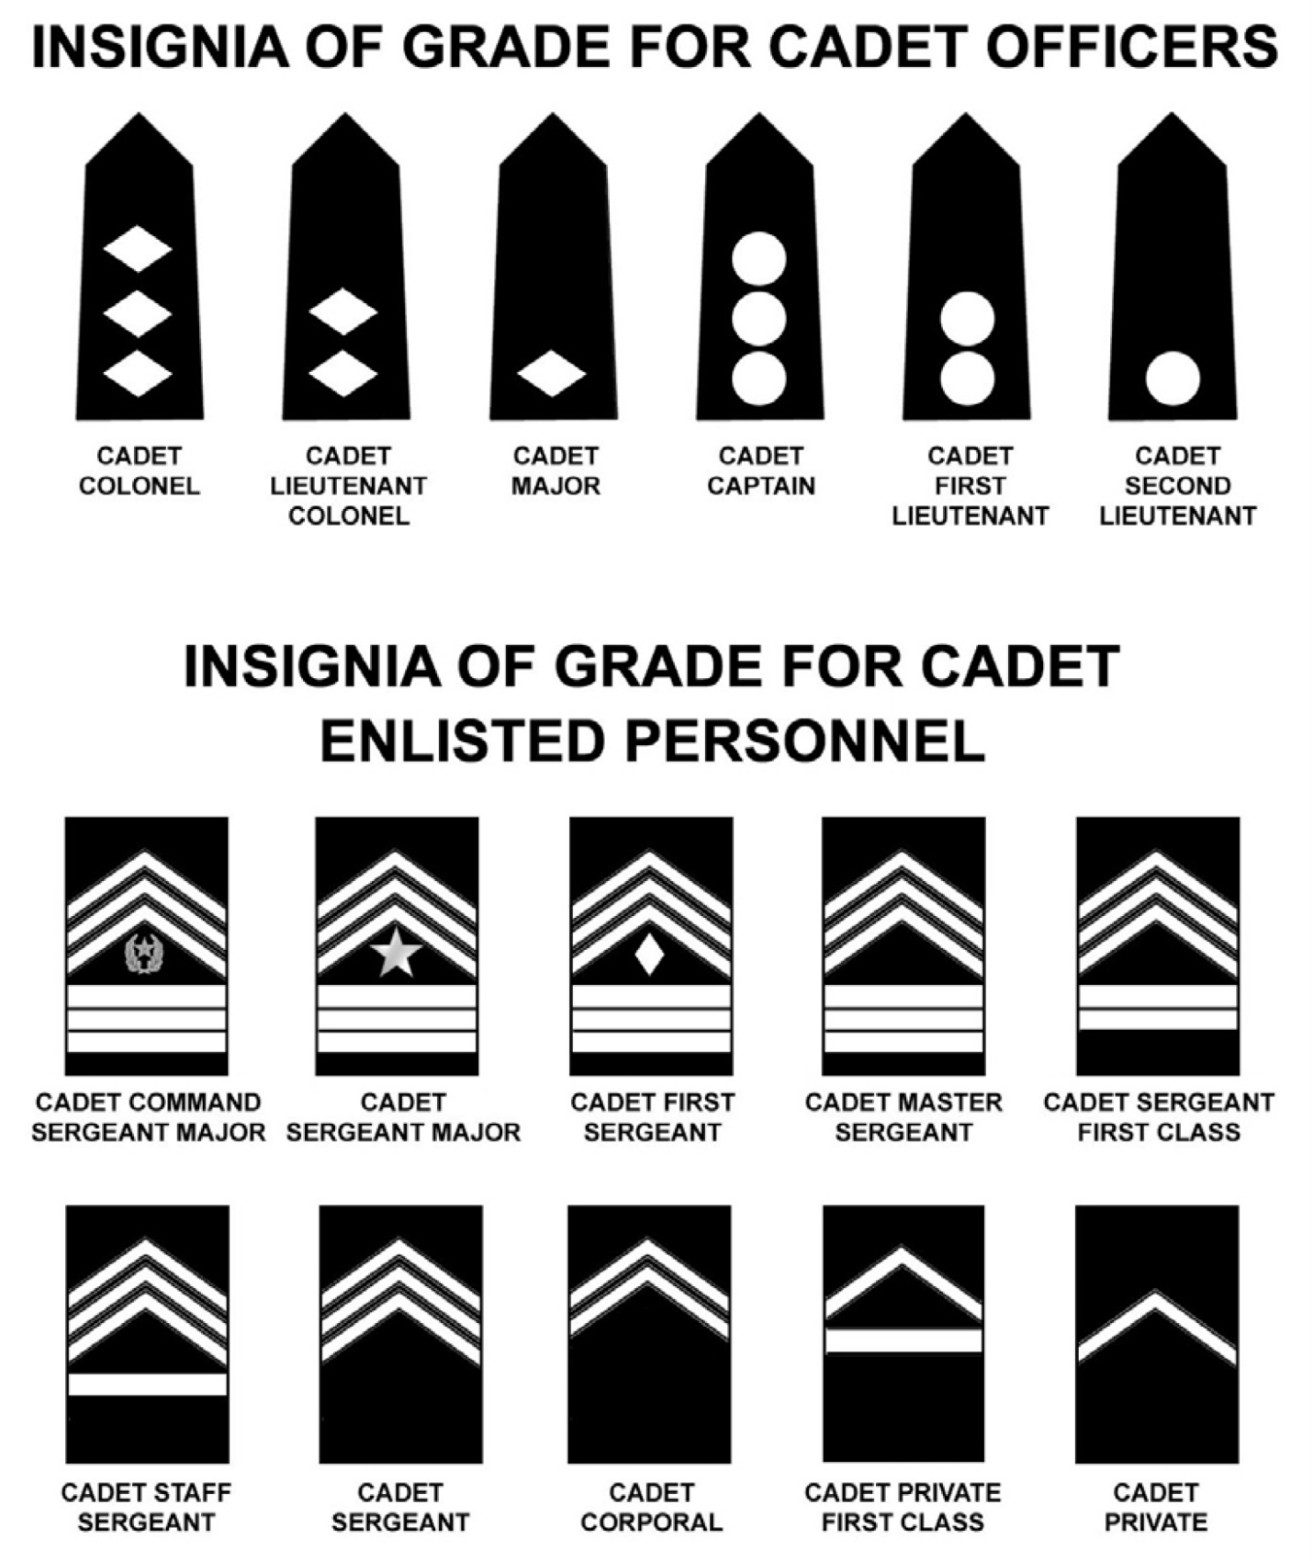

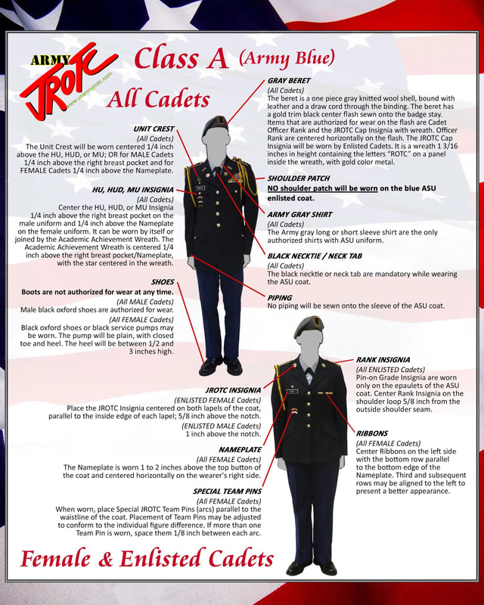

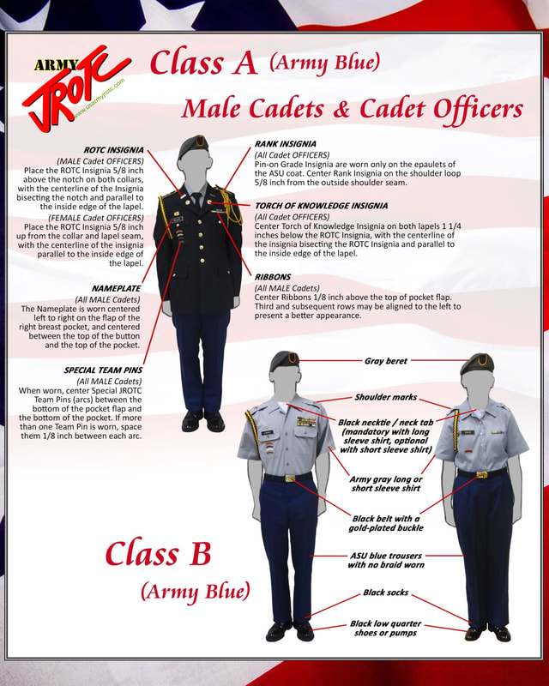

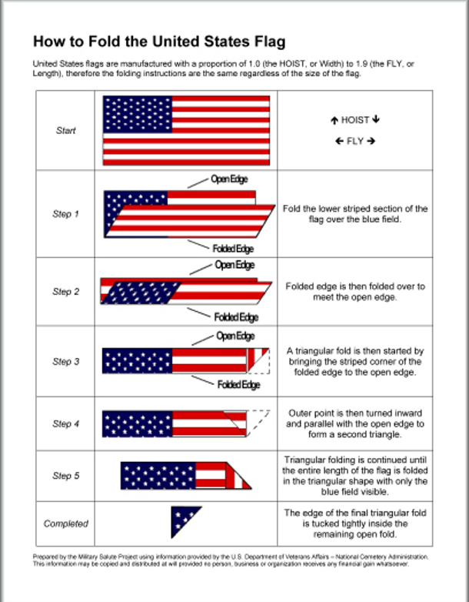

23 DRILL SEQUENCE
Movements/Commands
1. FALL IN (Leader faces about and awaits start signal from inspector)
2. Dress Right, DRESS (Checks for exact alignment)
3. Ready, FRONT (Leader ensures platoon is covered)
4. Present, ARMS
5. Order, ARMS
6. Left, FACE
7. About, FACE
8. Forward, MARCH
9. Column Left, MARCH
10. Left Flank, MARCH
11. Right Flank, MARCH
12. Column Right, MARCH
13. Right Flank, MARCH
14. Left Flank, MARCH
15. Column Right, MARCH
16. Rear, MARCH
17. Rear, MARCH
18. Column Right, MARCH
19. Column Left, MARCH
20. Column Left, MARCH
21. Squad/Platoon, HALT
22. (Leader faces unit, then commands) Left, FACE
23. FALL OUT

